 | RIVER VALLEY HIGH SCHOOL  YEAR 6 PRELIMINARY EXAMINATION

CANDIDATE NAME
CLASS | 6

CENTRE NUMBER | S |  |  |  |  |  | INDEX NUMBER

H2 CHEMISTRY |  |  | 9647/03
Paper 3 Free Response |  |  | 16 September 2010  2 hours
Candidates answer on separate paper.
Additional Materials: | Answer Paper  Graph Paper  Cover Page  Data Booklet
READ THESE INSTRUCTIONS FIRST

Write your name, class, Centre number and index number on all the work you hand in.
Write in dark blue or black pen on both sides of paper.
You may use a soft pencil for any diagrams, graphs or rough working.
Do not use staples, paper clips, highlighters, glue or correction fluid.

Answer any four questions.
Begin each question on a fresh sheet of paper.
A Data Booklet is provided. Do not write anything on it.
You are reminded of the need for good English and clear presentation in your answers.

The number of marks is given in brackets [ ] at the end of each question or part question.
At the end of the examination, fasten all your work securely together, with the cover page on top.

_______________________________________________________________________________
This document consists of 12 printed pages.

Answer any four questions.

1 | The halogens chlorine, bromine and iodine were discovered in the late 18th and early 19th centuries.
 | (a) | Chlorine was first isolated by Carl Wilhelm Scheele in 1774. Scheele reacted manganese(IV) oxide, MnO₂, with hydrochloric acid and isolated chlorine gas from the products.  In an experiment, 1.00 g of manganese(IV) oxide was reacted with an excess of hydrochloric acid to form 276 cm³ of chlorine gas measured at room temperature and pressure.  Use these data to determine the oxidation number of manganese in the manganese-containing product and hence write a balanced equation for the reaction. |  | [3]
 | (b) | Iodine was discovered by Bernard Courtois in 1811 when he poured an excess of concentrated sulfuric acid onto seaweed ash containing iodide salts.
 |  | (i) | Write balanced equations for the reactions that occurred.
 |  | (ii) | With reference to the Data Booklet, explain why Coutois would not be able to isolate chlorine by the action of concentrated sulfuric acid on sodium chloride.
 |  |  |  | [3]
 | (c) | Bromine was isolated by Carl Jacob Lowig in 1825 from a sample of mineral salt solution containing bromides that he saturated with chlorine.  Write an ionic equation for the extraction of bromine by the above method. |  | [1]
 | (d) | The isolation of fluorine was reported only much later in 1886 by Henri Moissan, after almost 74 years of effort by other chemists.  Suggest, with the aid of the Data Booklet, why it was difficult to isolate fluorine and a method by which it could be isolated from sodium fluoride. A detailed description of the method is not required. |  | [2]
 | (e) | Chlorine, bromine and iodine react with hydrogen under different conditions and to a different extent.  State the conditions for the three separate reactions and suggest a reason for the different conditions. |  | [4]

 | (f) | Contrary to popular belief, the Germans were not the first to use chemical weapons during World War I. The French used 4-methylbenzyl bromide as a tear gas to clear trenches in 1914.  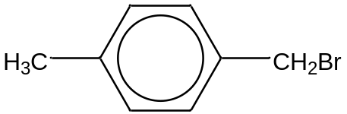  4-methylbenzyl bromide  Describe simple chemical tests you could carry out to distinguish 4-methylbenzyl bromide from the following compounds.  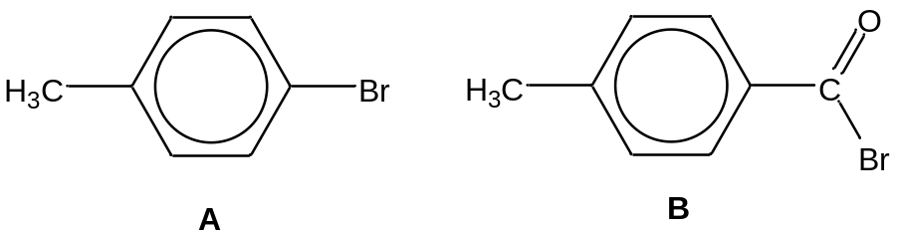 |  | [4]
 | (g) | Chlorides of Period 3 elements have different behaviour when mixed with water.  Give the pH of the resulting solution when magnesium chloride and phosphorus(V) chloride are each added to water. Write equations for any reactions that may occur. |  | [3]
 |  |  | [Total: 20]

2 | Sulfur is an element which is abundant and essential for life. It can react with many other elements to form many sulfur-containing compounds. Its commercial uses are primarily in fertilisers, but it is also widely used in black gunpowder, matches, insecticides and fungicides.
 | (a) | Sulfur dioxide, SO₂, and sulfur trioxide, SO₃, are oxides of sulfur.
 |  | (i) | Draw a dot-and-cross diagram to show the bonding in sulfur trioxide and suggest its shape.
 |  | (ii) | The table below shows the boiling points of the two oxides of sulfur.  Explain the difference in the boiling points in terms of their structures and bonding.
  compound | boiling point /°C
  sulfur dioxide | −10
  sulfur trioxide | 45
 |  |  |  | [4]
 | (b) | The tertiary structure of a protein is formed due to side chain interactions, such as disulfide bridges.
 |  | (i) | Explain what is meant by the term tertiary structure of a protein.
 |  | (ii) | The cysteine residues in proteins can form disulfide bridges.  Using the cysteine residue shown below, construct an equation to show the formation of the disulfide bridge between two cysteine residues.  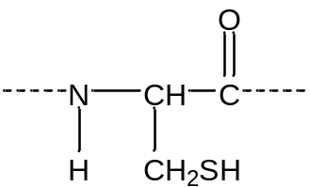
 |  | (iii) | Other than the disulfide interaction, state three other types of side chain interactions that can be found in the tertiary structure of a protein.
 |  | (iv) | Denaturation of proteins involves the disruption and possible destruction of the tertiary structure of the protein. This can be caused by the addition of heavy metal ions or extreme pH changes.  Explain, in chemical terms, how side chain interactions are broken by the addition of heavy metal ions.
 |  |  |  | [7]

 | (c) | Mercaptopurine, C₅H₄N₄S, is an immunosuppresive drug that inhibits or inactivates the immune system. It is used in immunosuppression therapy to prevent the rejection of transplanted organs and tissues.  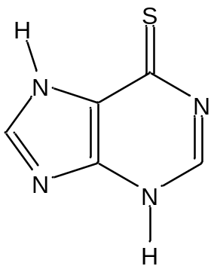  mercaptopurine (melting point: 313 °C; boiling point: 430 °C)  Combustion of mercaptopurine produces carbon dioxide, sulfur dioxide, nitrogen gas and water.
 |  | (i) | Define, with the aid of an equation, the standard enthalpy change of combustion of mercaptopurine.
 |  | (ii) | Using the following information, and relevant data from the Data Booklet, calculate the standard enthalpy change of combustion of mercaptopurine.
  bond energy of S=O | +128 kJ mol⁻¹
  bond energy of C=S | +138 kJ mol⁻¹
 |  | (iii) | When 1.50 g of mercaptopurine was combusted in a calorimeter, the energy evolved heated 100 cm³ of water from 25 °C to 87 °C.  Given that this process is only 65% efficient, use these data and values from the Data Booklet to calculate the enthalpy change of combustion of mercaptopurine.
 |  | (iv) | Suggest two reasons for the difference in the values obtained in (c)(ii) and (c)(iii).
 |  |  |  | [9]
 |  |  | [Total: 20]

3 | The black-and-white (B/W) photography process involves four steps:
 | Step 1 |  | Phototaking: Interaction of light with silver halides (AgX) on film.
 | Step 2 |  | Developing: Redox reactions to develop the actual image.
 | Step 3 |  | Fixing: Changing the solubility of chemical compounds with different conditions to preserve the image on the film.
 | Step 4 |  | Printing: Shining light through the film onto photosensitive paper, producing the final photograph using the same chemistry as steps 1 to 3.
 | (a) | When light is shone on the film during the phototaking process, a very small number of X ⁻ ions in the AgX are oxidised.  Write a balanced half equation to show the oxidation reaction of X ⁻ to a radical by light. |  |  | [1]
 | (b) | A small amount of silver is produced as a result of the oxidation reaction of X ⁻. The silver produced catalyses the reduction of the surrounding AgX to black silver metal in the presence of a reducing agent, Y, during the developing process.  2AgX + Y + 2OH⁻ → 2Ag + Z + 2H₂O + 2X ⁻
 |  | (i) |  | State and explain why the rate of reaction changes as the developing process proceeds.
 |  | (ii) |  | Z, formed from the oxidation of Y, has the molecular formula C₆H₄O₂. Z forms a yellow precipitate when warmed with 2,4-dinitrophenylhydrazine. 1 molar equivalent of Z decolourises 2 molar equivalents of bromine dissolved in tetrachloromethane. Heating Z with acidified potassium manganate(VII) gives rise to two identical molecules.  Y has the molecular formula C₆H₆O₂. It is insoluble in water but can dissolve in the aqueous sodium hydroxide used in the developing process. Addition of sodium carbonate to Y does not result in effervescence but addition of sodium metal to Y gives mild effervescence.  Suggest the structures of Y and Z, explaining your reasoning.
 |  |  |  |  | [9]

 | (c) | The developing process is stopped by dipping the film into an acidic buffer, also known as the ‘stopper’. This removes the hydroxide ions present and stops the reduction process by Y.  The ‘stopper’ is prepared by mixing 1 dm³ of 1.0 mol dm⁻³ ethanoic acid with 1 dm³ of 1.0 mol dm⁻³ sodium ethanoate.  [K_{a} of ethanoic acid = 1.8 × 10⁻⁵ mol dm⁻³]
 |  | (i) | Calculate the pH of the ‘stopper’.
 |  | (ii) | This ‘stopper’ cannot be used indefinitely. Once the pH of the ‘stopper’ rises above 5, it will be ineffective in stopping the reaction.  Each dip of the film into the ‘stopper’ will introduce 0.0500 mol of hydroxide ions.  Assuming that the total volume of solution and K_{a} for ethanoic acid remain unchanged, calculate the maximum number of dips possible with the prepared ‘stopper’ solution before it loses its effectiveness.
 |  |  |  | [4]
 | (d) | Fixing the image on the film involves removing unexposed AgX to leave the dark silver image. This is done by washing the developed film in aqueous sodium thiosulfate, Na₂S₂O₃, to form the dithiosulfatoargentate(I) complex ion, [Ag(S₂O₃)₂]³⁻.  Ag⁺(aq) + 2S₂O₃²⁻(aq)  [Ag(S₂O₃)₂]³⁻(aq) K_{c}(1) = 2.9 × 10¹³ mol⁻² dm⁶
 |  | (i) | Write an expression for the solubility product of AgX.
 |  | (ii) | Given that the solubility product of AgX is 1.0 × 10⁻¹⁰ mol² dm⁻⁶, calculate the amount of silver(I) ions, Ag⁺(aq), present in 1 dm³ of a saturated solution of AgX.
 |  | (iii) | Using the information from (d)(ii) and the equilibrium constant, K_{c}(1), given above, explain why AgX dissolves readily in aqueous sodium thiosulfate.
 |  |  |  | [4]

 | (e) | Photographs in the past were printed on nitrocellulose paper coated with photosensitive dyes. Nitrocellulose is made by nitrating cellulose with a mixture of concentrated sulfuric acid and concentrated nitric acid.  If only concentrated sulfuric acid was added to cellulose, a black solid would be obtained with the evolution of copious white fumes.  Suggest the identity of the black solid and the type of reaction undergone. |  | [2]
  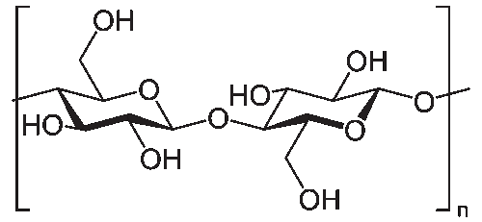 | 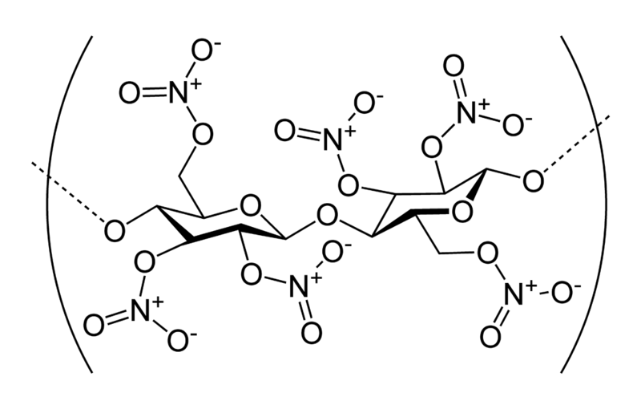  n
  cellulose | nitrocellulose
 |  |  | [Total: 20]

4 | Aromatic compounds are widely used in our daily lives. For example, 2,4,6-trinitromethylbenzene, also known as trinitrotoluene (TNT), is used as an explosive while phenylmethanol, C₆H₅CH₂OH, is used as a treatment for head lice as well as a solvent for many organic compounds.
 | (a) | Many aromatic compounds can be produced from methylbenzene as the starting material as shown in the reaction scheme below.  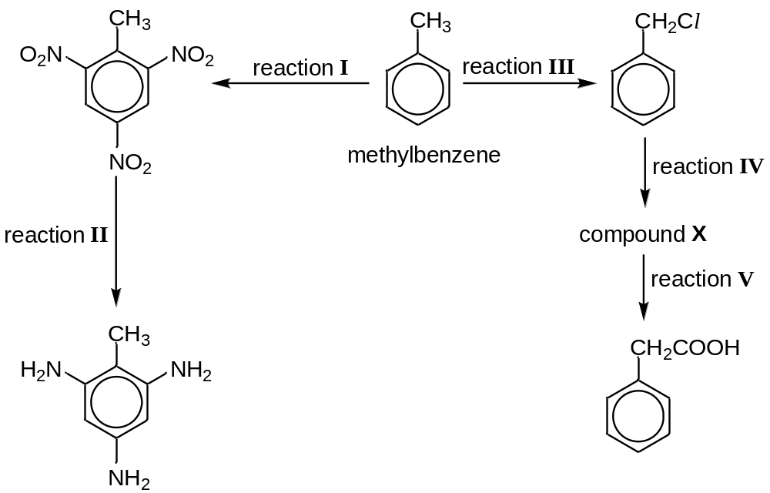
 |  | (i) | State the type of reaction and suggest suitable reagents and conditions for reaction II and III.
 |  | (ii) | Suggest a structure for compound X and hence, suggest suitable reagents and conditions for reaction IV.
 |  | (iii) | State the type of reaction and suggest suitable reagents and conditions for reaction V.
 |  |  |  | [8]
 | (b) | Phenylmethanol is produced when (chloromethyl)benzene, C₆H₅CH₂Cl, heated with aqueous sodium hydroxide.  To determine the orders of reaction with respect to (chloromethyl)benzene and hydroxide ions, two experiments were carried out and the following results were obtained. In each experiment, the overall concentration of sodium hydroxide remained virtually constant throughout the experiment.
  Time /min | Experiment 1  [C₆H₅CH₂Cl]/ mol dm⁻³ when [NaOH(aq)] = 0.10 mol dm⁻³ | Experiment 2  [C₆H₅CH₂Cl]/ mol dm⁻³ when [NaOH(aq)] = 0.15 mol dm⁻³
  0 | 0.0100 | 0.0150
  50 | 0.0079 | 0.0118
  100 | 0.0062 | 0.0091
  150 | 0.0049 | 0.0068
  200 | 0.0038 | 0.0053
  250 | 0.0030 | 0.0041
  300 | 0.0024 | 0.0033
 |  | (i) | Plot these data provided on suitable axes.
 |  | (ii) | Use your graphs to determine the order of reaction with respect to (chloromethyl)benzene and to sodium hydroxide, showing your working clearly.
 |  | (iii) | Deduce the rate equation for the reaction and calculate the rate constant, giving its units.
 |  | (iv) | State the type of reaction and describe the reaction mechanism based on the rate equation from (b)(iii). Use curly arrows to indicate the movement of electrons.
 |  | (v) | Briefly explain how the behaviour of 4-chloromethylbenzene with hot aqueous sodium hydroxide differs from that of (chloromethyl)benzene.
 |  |  | [12]
 |  |  | [Total: 20]

5 | Copper metal and alloys have been used for thousands of years. In the Roman era, copper was principally mined on Cyprus, hence the origin of the name of the metal as Cyprium, "metal of Cyprus", later shortened to Cuprum (hence the symbol Cu).  Being a transition element, its compounds are known in several oxidation states, usually +2, which impart the blue and sometimes green colours to the compounds.
 | (a) | Explain what is meant by the term transition element. |  | [1]
 | (b) | Explain why the hydrated copper(II) ion such as in copper(II) sulfate pentahydrate, CuSO₄.5H₂O, is coloured whereas copper(I) sulfate, Cu₂SO₄, is white. |  | [4]
 | (c) | With reference to the Data Booklet, describe and explain what is observed when copper(I) sulfate is added to water. |  | [2]
 | (d) | The colours of various vanadium ions are given in the table below.  Using data from the Data Booklet, predict and explain what final colour will be observed when copper metal is added in excess to acidified aqueous ammonium vanadate(V), NH₄VO₃. |  | [3]
  oxidation state | V | IV | III | II
  colour | yellow | blue | green | violet
 | (e) | The rate of reaction between iodide ions, I ⁻, and peroxodisulfate(VI) ions, S₂O₈²⁻,  2I ⁻(aq) + S₂O₈²⁻(aq) → 2SO₄²⁻(aq) + I₂(aq)  is increased by the presence of low concentrations of Cu²⁺(aq).
 |  | (i) | Suggest why the reaction is slow in the absence of Cu²⁺(aq).
 |  | (ii) | Suggest the role of Cu²⁺(aq) in this reaction.
 |  | (iii) | The deterioration in the air of some organic substances, such as cosmetics, is a similar process to that described above. Suggest why the deterioration can be slowed down by the addition of a small quantity of a ligand, ethylenediaminetetraacetic acid (EDTA).
 |  |  |  | [3]

 | (f) | Alkaline aqueous copper(II) complexes are used to test for the presence of an organic functional group.
 |  | (i) | State the functional group that reacts with this reagent.
 |  | (ii) | Construct a balanced half equation for the reduction of copper(II) ions in alkaline solution that occurs in tests for the functional group in (f)(i).
 |  |  |  | [2]
 | (g) | Most copper ore is mined as copper sulfides, from which copper is extracted. One method of determining the percentage of copper in a copper-containing ore is to dissolve the copper salts in an excess of dilute sulfuric acid, add an excess of potassium iodide, KI, and titrate the iodine formed with sodium thiosulfate, Na₂S₂O₃, solution.
 |  | (i) | Describe what you would observe when the potassium iodide is added to the solution of copper salts in sulfuric acid. Write an ionic equation for the reaction.
 |  | (ii) | When a 2.00 g sample of an ore was subjected to the above treatment, it was found that 15.8 cm³ of 0.100 mol dm⁻³ sodium thiosulfate was needed to react with the iodine produced.  Calculate the amount, and hence the percentage by mass, of copper in the sample.
 |  |  |  | [5]
 |  |  | [Total: 20]

END OF PAPER

